SMART AMBULANCE DISPATCH AND ROUTE OPTIMIZATION
A Project Based Learning Report Submitted in partial fulfilment of the requirements for the award of the degree
of
Bachelor of Technology
in Computer Science and Engineering
Data Structures and Algorithms – III (DSA-III)

Submitted by
Roll.no: [SEJAL HEDA - 2510030350]
Roll.no: [P BHAVYA - 2510030379]
Roll.no: [B SIRI - 2510030325]
Roll.no: [T-HANSIKA - 2510030330]
Roll.no: [M- MOUNIKA- 2510030343]
Under the guidance of
[Dr-M.SAIDI REDDY]


Department of Computer Science and Engineering
Koneru Lakshmaiah Education Foundation, Aziz Nagar
Aziz Nagar – 500075
OCT - 2026.
Abstract
The Smart Ambulance Dispatch and Route Optimization System is an emergency healthcare management platform designed to improve ambulance dispatch, hospital selection, bed allocation, and doctor assignment. The system integrates multiple Data Structures and Algorithms (DSA) into a single emergency-response workflow. A Priority Queue prioritizes emergencies based on severity, while Dijkstra’s algorithm determines efficient routes. Dinic’s Maximum Flow manages hospital bed capacity, and Bipartite Matching assigns suitable doctors based on specialization and availability. KMP and Edit Distance algorithms support exact and fuzzy patient-record searches.
The system is implemented using Python, FastAPI, SQLAlchemy, and SQLite, with REST APIs for authentication, ambulances, hospitals, doctors, patients, analytics, and emergency dispatch. A web-based dashboard allows administrators to monitor resources and manage emergency requests. The complete workflow follows Emergency Request → Priority Evaluation → Ambulance Assignment → Route Optimization → Hospital Selection → Bed Allocation → Doctor Assignment → Dispatch Result.
The project was tested locally and through the deployed application to verify database operations, API communication, resource management, and emergency dispatch functionality. Overall, the system demonstrates how DSA concepts can be practically integrated to solve a real-world emergency healthcare resource-allocation problem.

List of Figures
Figure 1. Overall Smart Ambulance system workflow
Figure 2. Admin login page
Figure 3. Admin dashboard and analytics
Figure 4. Ambulance management output
Figure 5. Hospital and doctor management output
Figure 6. Emergency dispatch and route output

List of Tables

Table 1. Functional modules and implemented technologies
Table 2. DSA algorithms used in the system
Table 3. Database entities
Table 4. Test cases and observed results

Table of Contents

1. INTRODUCTION
2. METHODOLOGY
2.1 System Overview
2.2 Technology Stack
2.3 Database Design
2.4 DSA Algorithm Implementation
2.5 Backend API and Frontend Integration
2.6 End-to-End Emergency Workflow
3. EXPERIMENTS
3.1 Experimental Setup
3.2 Functional Testing
3.3 DSA Testing
3.4 Emergency Dispatch Scenario
4. RESULTS
5. CONCLUSION AND FUTURE WORK
REFERENCES

SMART AMBULANCE DISPATCH AND ROUTE OPTIMIZATION

INTRODUCTION
Emergency medical response depends on making several decisions quickly: identifying the urgency of a request, selecting an appropriate ambulance, finding a practical route, choosing a hospital with the required specialization and available capacity, allocating a bed, and assigning a suitable doctor. When these decisions are handled independently, delays and resource conflicts can occur. The proposed Smart Ambulance Dispatch and Route Optimization system combines these decisions into one integrated workflow.
The main objective of the project is to demonstrate how advanced Data Structures and Algorithms can be applied to a realistic emergency healthcare scenario. The system uses a priority queue to process emergencies according to severity, graph-based shortest-path computation for route selection, assignment and matching techniques for resource allocation, maximum flow for hospital-bed capacity, and string algorithms for medical-record search. These algorithms are connected through a FastAPI backend and a web-based administrative interface.
The implementation is designed as a practical prototype rather than a theoretical simulation. Data for ambulances, hospitals, doctors, patients and emergency requests is stored through SQLAlchemy. The backend exposes REST endpoints for login, dashboard analytics, resource listing and emergency dispatch. The frontend communicates with these APIs and presents the results through an administrative dashboard.
The project also supports concurrent emergency handling. Critical requests receive higher priority, available resources are considered before assignment, and hospital capacity is checked before a dispatch is finalized. This creates a complete path from an emergency request to a final dispatch decision and connects the DSA concepts studied in the course with a meaningful application domain.
The project scope includes algorithm implementation, backend integration, database management, frontend integration, testing and deployment validation. It is intended for academic demonstration and does not replace real emergency medical dispatch software or real-time hospital systems.

METHODOLOGY

System Overview
The system follows an end-to-end pipeline: Emergency Request → Priority Scoring → Ambulance Assignment → Route Optimization → Hospital Selection → Bed Allocation → Doctor Assignment → Dispatch Result. Each stage consumes the result of the previous stage and contributes information to the final emergency response.
The architecture is divided into an input layer, algorithm engine, database/backend layer and output layer. The input layer collects emergency details such as patient information, severity, location and required specialization. The algorithm engine applies the required DSA techniques. The backend manages persistent data and exposes APIs. The output layer returns the selected ambulance, route, hospital, bed and doctor information to the dashboard.

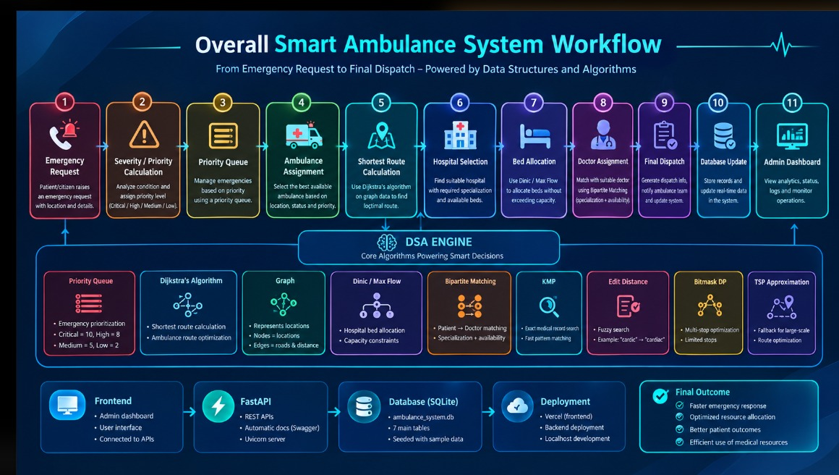
Figure 1. Overall Smart Ambulance system workflow

Technology Stack
Layer | Technology / Component | Purpose
Programming language | Python | Backend and DSA implementation
Backend | FastAPI + Uvicorn | REST API and application server
ORM / Database | SQLAlchemy + SQLite | Persistent storage and database access
Algorithms | Priority Queue, Dijkstra, Dinic, Matching, KMP, Edit Distance, DP | Emergency allocation, routing, capacity and search
Frontend | Web-based administrative dashboard | Login, monitoring, resource views and dispatch
Development | PowerShell / VS Code | Local development and testing
Deployment | Vercel / hosted validation | Deployment testing after integration

Database Design
The backend uses SQLite through SQLAlchemy. The local database file is ambulance_system.db. The database contains entities for administrators, hospitals, ambulances, patients, emergencies, doctors and dispatch records. SQLAlchemy models provide a structured interface between the Python application and the database.
Entity | Important information | Role
admin_users | username, password_hash | Administrative authentication
hospitals | name, address, location, specializations, total_beds, available_beds | Hospital selection and capacity
ambulances | ambulance_code, status, latitude, longitude, driver details | Ambulance availability and dispatch
doctors | name, specialization, availability, hospital_id | Doctor matching
patients | patient_id, name, age, phone, medical_history | Patient and medical-record search
emergencies | request details and status | Emergency tracking
dispatches | selected resources and dispatch result | Final dispatch record

DSA Algorithm Implementation
The implementation follows the algorithms defined during the project design and connects them to actual backend operations.
Algorithm | Implementation role | Expected benefit
Priority Queue | Orders emergencies by severity and priority score | Critical emergencies are handled first
Dijkstra | Finds shortest route in the road graph | Efficient route selection
Assignment / Matching | Pairs emergencies with suitable ambulances and doctors | Suitable resource allocation
Dinic / Max Flow | Models patient-to-hospital capacity constraints | Prevents allocation beyond available beds
Bipartite Matching | Matches patients/emergencies with compatible doctors | Uses specialization and availability
KMP | Exact search in patient medical records | Fast pattern matching
Bitmask DP / multi-stop DP | Represents multi-stop routing states | Supports multi-location routing
TSP approximation | Fallback for larger routing cases | Scalable multi-stop planning

Priority Queue and Emergency Handling
Each emergency is assigned a priority based on severity. The project priority values are Critical = 10, High = 8, Medium = 5 and Low = 2. A priority queue ensures that higher-priority requests are considered before lower-priority requests. This is particularly important when multiple emergencies arrive at approximately the same time.
The emergency router coordinates the priority decision with resource availability. Before dispatching, the backend checks available ambulances, suitable hospitals, bed capacity and doctor availability. This prevents the algorithm from producing a dispatch that cannot actually be completed.

Graph Representation and Dijkstra Routing
The road network is represented as a weighted graph. Nodes represent locations and edges represent connections between locations with a travel cost or distance. Dijkstra’s algorithm repeatedly selects the unvisited node with the smallest known distance and relaxes its outgoing edges. The final distance and predecessor information are used to reconstruct the selected route.
The route component is connected to ambulance positions and emergency destinations. For larger multi-stop cases, the project design also includes bitmask-based dynamic programming and TSP approximation concepts.

Hospital Selection and Dinic Max Flow
Hospital selection considers specialization and available beds. A hospital with zero available beds must not be selected when admission is required. The maximum-flow model represents a source connected to patients, patients connected to eligible hospitals, and hospitals connected to the sink with capacities corresponding to available beds. Dinic’s algorithm calculates feasible allocation while respecting capacity constraints.
The seeded local dataset includes hospitals with different capacities, including a hospital with zero available beds. This allows the capacity-rejection logic to be demonstrated.

Doctor Assignment Using Bipartite Matching
Doctor assignment is modeled as a bipartite matching problem. One side represents patients or emergency cases and the other side represents available doctors. An edge is considered when the doctor’s specialization and availability are compatible with the emergency. Matching attempts to assign a doctor without reusing a doctor in the same matching operation.

KMP and Edit Distance Medical Search
The medical-record search module contains two levels of search. KMP is used for exact substring matching, while Edit Distance is used for approximate matching. A spelling variation such as 'cardic' can therefore be compared with stored terms such as 'cardiac'. The combination demonstrates both exact pattern matching and fuzzy search using DSA techniques.

Backend API and Frontend Integration
The FastAPI backend provides REST endpoints for authentication, dashboard analytics, ambulances, hospitals, doctors, patients and emergency dispatch. The local server is started through run.py using Uvicorn and serves the FastAPI application on the local host. The frontend calls these APIs to display resource information and dispatch results.
The project was also deployment-tested after local integration. The local SQLite database remains the primary development database for the academic prototype, while hosted deployment is treated as an additional validation environment.

End-to-End Emergency Workflow
A typical request begins when an operator submits an emergency with severity, location and required medical specialization. The priority queue determines urgency. The ambulance module filters available ambulances and selects a suitable resource. Dijkstra computes a route. The hospital module filters hospitals by specialization and capacity. The bed allocation logic verifies capacity, and the doctor matching module identifies an available compatible doctor. The final response is returned through the API and displayed in the dashboard.
This workflow demonstrates integration rather than isolated algorithm execution. Each DSA module contributes a decision that is required by the next stage.

EXPERIMENTS

Experimental Setup
The system was developed and tested on Windows using Python 3.13, FastAPI, Uvicorn, SQLAlchemy and SQLite. The backend is organized into an app package containing database models, schemas, routers and DSA modules. The project also includes a seed script that creates the local schema and inserts demonstration data.
The seeded dataset contains six ambulances, six hospitals, nine doctors and four patient records. Three ambulances are initially available and three are busy. Hospital records contain different specializations and bed capacities so that both successful allocation and capacity-rejection cases can be demonstrated.

Functional Testing
Test | Action | Expected result | Observed status
Authentication | Login using configured admin credentials | Admin login returns success token | Passed locally
Dashboard | Open analytics after login | Dashboard data loads from API | Passed locally
Ambulances | Request /api/ambulances | Ambulance records are returned | Passed locally
Hospitals | Request /api/hospitals | Hospital records are returned | Passed locally
Doctors | Request /api/doctors | Doctor records are returned | Passed locally
Emergency dispatch | Submit valid emergency request | Dispatch result is generated | Tested; validation applies
Invalid dispatch | Submit incomplete/invalid request | API returns validation/error response | Handled

DSA Testing
The DSA modules are kept as separate Python files so each algorithm can be tested independently before being used by the API layer. The project contains modules for bipartite matching, Dijkstra, Dinic max flow, edit distance, graph representation, KMP and priority queue. This modular structure makes debugging and academic demonstration easier.
Module | Algorithm | Test focus
priority_queue.py | Priority Queue | Emergency ordering
dijkstra.py / graph.py | Dijkstra + graph | Shortest-path computation
dinic.py | Dinic Max Flow | Capacity-constrained allocation
bipartite.py | Bipartite Matching | Doctor/resource matching
kmp.py | KMP | Exact pattern search
edit_distance.py | Edit Distance | Fuzzy matching
test_dsa.py | DSA test suite | Algorithm-level validation

Emergency Dispatch Scenario
The demonstration scenario contains multiple emergencies with different priorities. A critical cardiac case receives priority 10, a high-priority road accident receives 8, and a medium-priority surgical case receives 5. The priority queue therefore processes the critical case first. Ambulance availability, shortest route, hospital specialization, bed capacity and doctor compatibility are checked before the final dispatch is returned.
The scenario demonstrates why combining algorithms is useful: Priority Queue decides order, Assignment selects a resource, Dijkstra handles routing, Dinic verifies capacity, Bipartite Matching handles doctor assignment, and dynamic scheduling concepts support multiple emergencies.

RESULTS
The final implementation connects the major DSA components with a working backend and administrative interface. Local API testing confirmed successful authentication and successful retrieval of ambulance, doctor and hospital data after the database was correctly seeded. The system therefore demonstrates the intended end-to-end architecture.
The following output figures are intentionally left as blank spaces. The final report should contain screenshots captured from the working application rather than screenshots of source code. Each screenshot should be cropped so that the relevant output is readable and unnecessary desktop content is excluded.
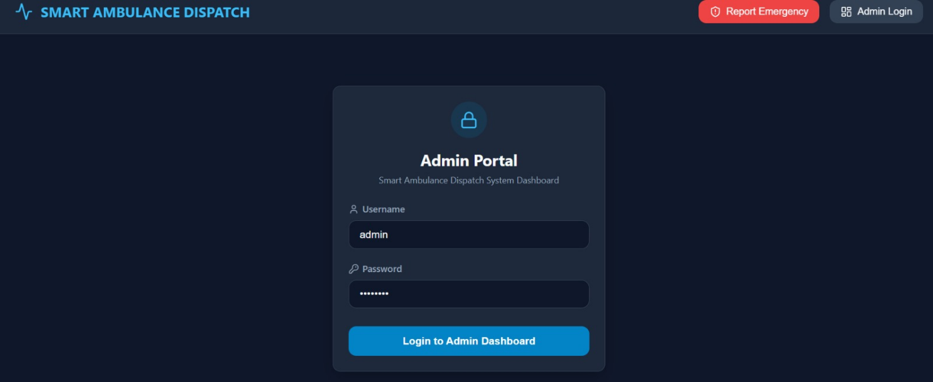
Figure 2. Admin login page showing the working login form

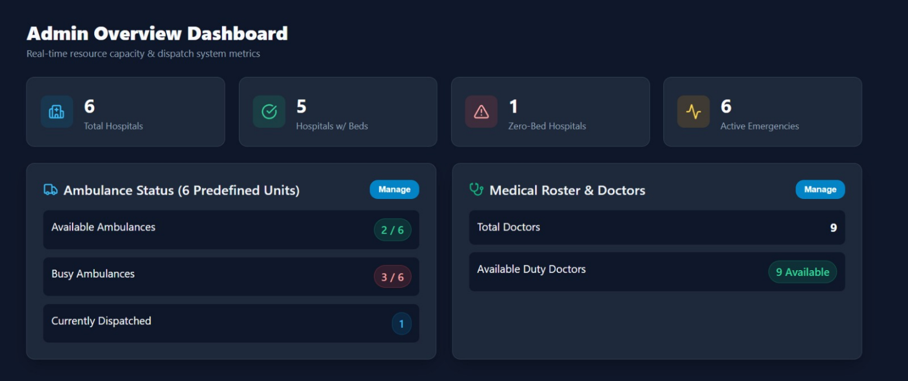
Figure 3. Admin dashboard showing analytics and system summary
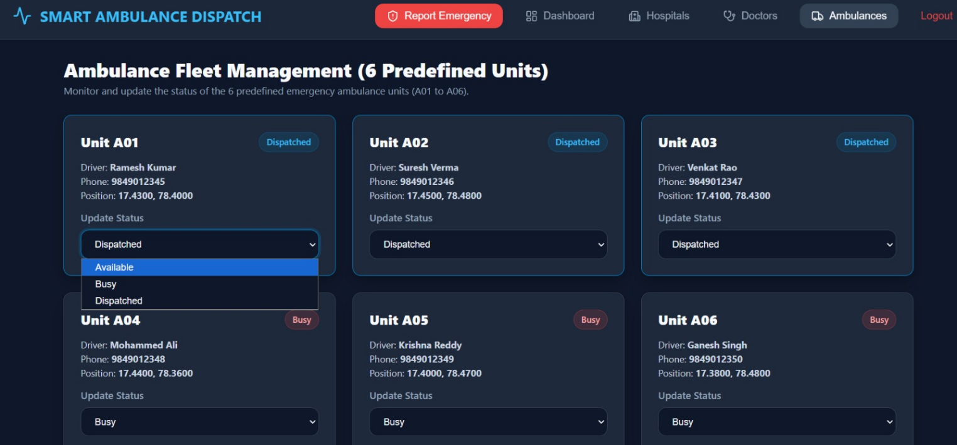
Figure4. Ambulance management page showing available and busy ambulances
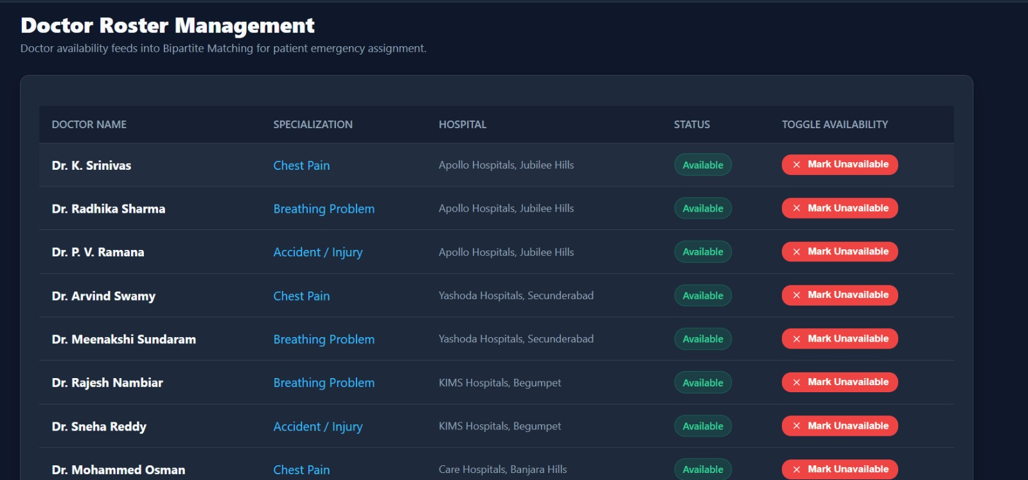Figure 5. Hospital and doctor data displayed by the application
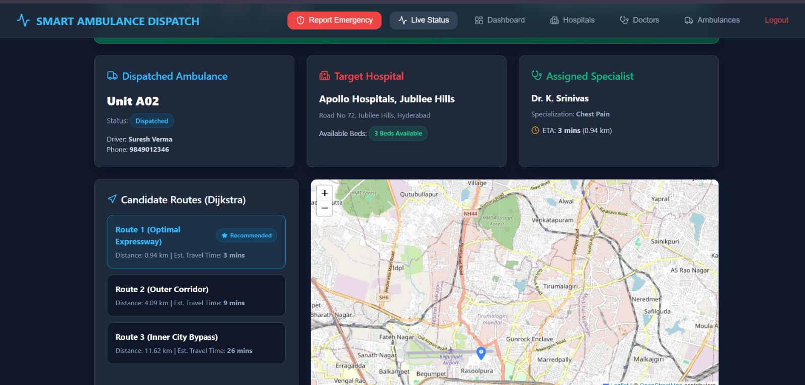
Figure 6. Emergency dispatch output showing selected ambulance, route and hospital

Implementation Summary
The completed prototype can be started locally from the backend directory using the project run script. The server launches through Uvicorn and the FastAPI application handles requests from the frontend. The database is created locally as ambulance_system.db, while seed.py can recreate the demonstration dataset when required. The local environment is recommended for classroom demonstration because it provides direct access to the database and avoids dependence on hosted database storage.
The implementation demonstrates that the project is not limited to a collection of algorithm programs. The algorithms are connected to real application modules: priority queues control emergency order, graph algorithms support routing, flow algorithms manage capacity, matching algorithms allocate doctors, and string algorithms support medical search.

CONCLUSION AND FUTURE WORK
The Smart Ambulance Dispatch and Route Optimization system provides an integrated demonstration of advanced Data Structures and Algorithms in an emergency healthcare application. The project combines priority-based emergency handling, shortest-path routing, resource assignment, maximum-flow bed allocation, bipartite doctor matching, exact and fuzzy medical search, and multi-emergency scheduling. These components are exposed through a FastAPI backend and connected to a web-based administrative dashboard.
The local implementation demonstrates the complete application flow and provides a reproducible environment for project evaluation. The modular architecture also makes it possible to test each algorithm independently and then verify its behavior when integrated with the application.
Future work can include real-time GPS and traffic integration, live hospital bed synchronization, stronger authentication with hashed passwords and token expiry, cloud-hosted relational storage, notification services, ambulance tracking, real-time dispatch updates, and improved route optimization using live road conditions. A production healthcare deployment would also require extensive validation, security controls, privacy protection and integration with authorized healthcare systems.

REFERENCES
[1] T. H. Cormen, C. E. Leiserson, R. L. Rivest and C. Stein, Introduction to Algorithms, MIT Press.
[2] E. W. Dijkstra, “A Note on Two Problems in Connexion with Graphs,” Numerische Mathematik, 1959.
[3] J. Edmonds and R. M. Karp, “Theoretical Improvements in Algorithmic Efficiency for Network Flow Problems,” Journal of the ACM, 1972.
[4] FastAPI Documentation, FastAPI framework for building APIs with Python.
[5] SQLAlchemy Documentation, Python SQL toolkit and Object Relational Mapper.
[6] Python Software Foundation, Python Documentation.
[7] SQLite Documentation, SQLite database engine documentation.
[8] Smart Ambulance Dispatch and Route Optimization, DSA-III Review 2 project design and algorithm mapping.

